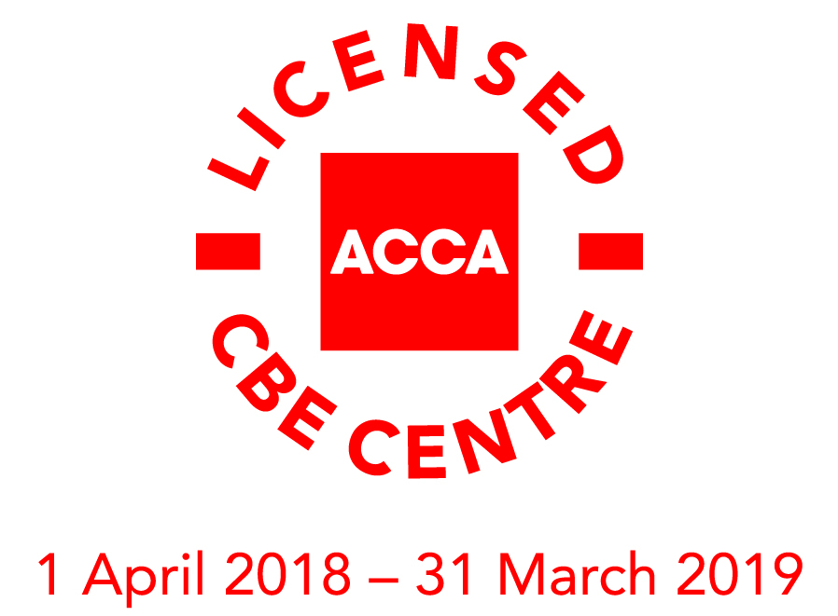


CBT ACCA

CANDIDATE REGISTRATION FORM

I would like to apply for (please tick):

ACCA Qualification

Accountant in Business (AB)
Management Accounting (MA)
Financial Accounting (FA)
Corporate & Business Law (LW) ENG
Corporate & Business Law (LW) GLO

Foundations in Accountancy

FA1
MA1
FA2
MA2
FAB
FFA
FMA

CANDIDATE DETAILS:
FIRST NAME |  | FAMILY NAME(S)
 |  | EXAM DATE
  ACCA
  REGISTRATION
  NUMBER
DATE OF BIRTH |  | GENDER | Male |  |  | Female
EMAIL ADDRESS |  |  | MOBILE PHONE NUMBER
ADDRESS |  |  | CITY/TOWN
ADDRESS |  |  | POST CODE
ADDRESS |  |  | COUNTRY

Do you have any special requirements? For example, modified materials for visual difficulties, or special requirements because of a medical condition.

CONDITIONS OF REGISTRATION

I have received, read and understood in full the Information sheet for CBE students.
Signature | Date

REGISTRATION, DEADLINES AND PAYMENT INFORMATION

Please send filled registration form to exams@britishcouncil.ba prior to the registration deadline announced on the web site www.britishcouncil.ba

The number of candidates taking the test in each session is limited so we suggest you register as soon as possible.

PRICE LIST

Exam | Price
FA1, FA2, MA1, MA2 | 300.00 BAM
FAB, FFA, FMA, AB, MA, FA | 300.00 BAM
LW (ENG/GLO) | 300.00 BAM

PAYMENT INFO

Fee can be paid by:
- Bank transfer
- Invoice

REFUND
All examination fees paid are non-refundable. Refunds will not be issued for incorrect choice of examination or subject.

We will only consider applications for refunds made on the following grounds:

- Medical – hospital admission or serious injury
- Loss or bereavement – death of parents, guardian, brother/sister or child

Applications for refund must be made at least 3 days before the exam date. A 25% administration fee is applicable on all refunds of the exam.
If you do not attend the examination for any reason other than the ones mentioned above, you will lose the fee that you have paid to the British Council. If you are unable to attend due to sickness, you must call the British Council immediately and present a note from a medical practitioner in order to avoid losing the fees you have paid.

